Date: 2012-06-25

Below new screen for RF Picking:
Please note we had added Wave (Opt) field ,
Picker can scan Wavekey to pick by Wave, or leave it empty then skip to Rack# to pick by rack#

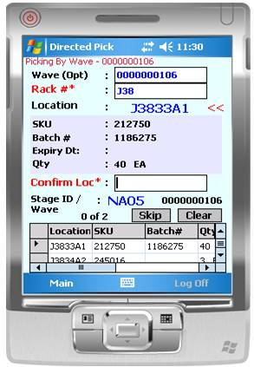

Add Wavekey Barcode;
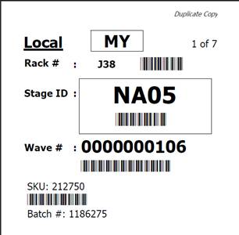
Wavekey barcoded

